6.2 Code Coverage with JaCoCo
This section will guide you to:
- Perform code coverage using JaCoCo in Jenkins for a Maven application.

This guide has five subsections, namely:
6.2.1 Login to Jenkins
6.2.2 Adding JaCoCo in Jenkins
6.2.3 Adding JaCoCo in Maven project
6.2.4 Creating Jenkins job for Maven
6.2.5 Push code to GitHub repositories
Step 6.2.1: Login to Jenkins
- Open your browser and navigate to localhost:8081
- Provide your username and password and click on Login.
Step 6.2.2: Add JaCoCo plugin in Jenkins
- Navigate to Manage Jenkins -> Plugin Manager -> Available and find JaCoCo Plugin.
- Restart Jenkins.
Step 6.2.3: Adding JaCoCo in Maven project
- Create a maven project by executing the following command
mvn archetype:generate -DgroupId=CodeCoverageDemo -DartifactId= MathOperations -DarchetypeArtifactId=maven-archetype-quickstart -DinteractiveMode=false
- Navigate to the maven project as shown below:
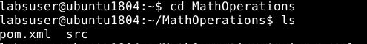

- Add the below code in the pom.xml file of your Maven project:

<project xmlns="http://maven.apache.org/POM/4.0.0" xmlns:xsi="http://www.w3.org/2001/XMLSchema-instance"
xsi:schemaLocation="http://maven.apache.org/POM/4.0.0 http://maven.apache.org/maven-v4_0_0.xsd">
<modelVersion>4.0.0</modelVersion>
<groupId>CodeCoverageDemo</groupId>
<artifactId>MathOperations</artifactId>
<packaging>jar</packaging>
<version>1.0-SNAPSHOT</version>
<name>MathOperations</name>
<url>http://maven.apache.org</url>
<properties>
<jacoco.version>0.7.5.201505241946</jacoco.version>
<junit.version>4.12</junit.version>
</properties>

<dependencies>
<dependency>
<groupId>junit</groupId>
<artifactId>junit</artifactId>
<version>${junit.version}</version>
<scope>test</scope>
</dependency>
</dependencies>
<build>
<plugins>
<plugin>
<groupId>org.apache.maven.plugins</groupId>
<artifactId>maven-compiler-plugin</artifactId>
<version>3.6.1</version>
<configuration>
<skipMain>true</skipMain>
<skip>true</skip>
<source>1.8</source>
<target>1.8</target>
</configuration>
</plugin>
<plugin>
<groupId>org.jacoco</groupId>
<artifactId>jacoco-maven-plugin</artifactId>
<version>${jacoco.version}</version>
<executions>
<execution>
<id>prepare-agent</id>
<goals>
<goal>prepare-agent</goal>
</goals>
</execution>
<execution>
<id>report</id>
<phase>prepare-package</phase>
<goals>
<goal>report</goal>
</goals>
</execution>
<execution>
<id>post-unit-test</id>
<phase>test</phase>
<goals>
<goal>report</goal>
</goals>
<configuration>
<!-- Sets the path to the file which contains the execution data. -->

<dataFile>target/jacoco.exec</dataFile>
<!-- Sets the output directory for the code coverage report. -->
<outputDirectory>target/jacoco-ut</outputDirectory>
</configuration>
</execution>
</executions>
<configuration>
<systemPropertyVariables>
<jacoco-agent.destfile>target/jacoco.exec</jacoco-agent.destfile>
</systemPropertyVariables>
</configuration>
</plugin>
</plugins>
</build>
</project>

- Navigate to /MathOperations/src/main/java/CodeCoverageDemo and run the following command:
rm App.java
- Create a file Operations.java using the below command
vi Operations.java
- Add the following code in Operations.java file
package CodeCoverageDemo;

public class Operations {

public Integer add(Integer a, Integer b)
{
return a+b;
}

}

- Navigate to /MathOperations/src/test/java/CodeCoverageDemo and run the command given below.
rm AppTest.java
- Create a file Operations.java using the below command
vi OperationsTest.java
- Add the following code in OperationsTest.java file

package CodeCoverageDemo;
import org.junit.Test;
import static org.junit.Assert.assertEquals;

public class OperationsTest {

@Test
public void testAdd()
{
Operations operations = new Operations();
Integer actual = operations.add(2, 6);
Integer expected = 8;
assertEquals(expected, actual);
}
}

Step 6.2.4: Creating Jenkins job for Maven
- To create a new job in Jenkins, open the Jenkins dashboard with your Jenkins URL. For example, http://localhost:8081/.
- Click on Create New Job. Enter the item name, select Maven Project and click OK.
- Once you click OK, the page will be redirected to its project form. Here, you will need to enter the project information.
- In the Build section enter the path to the pom.xml file in your local system.
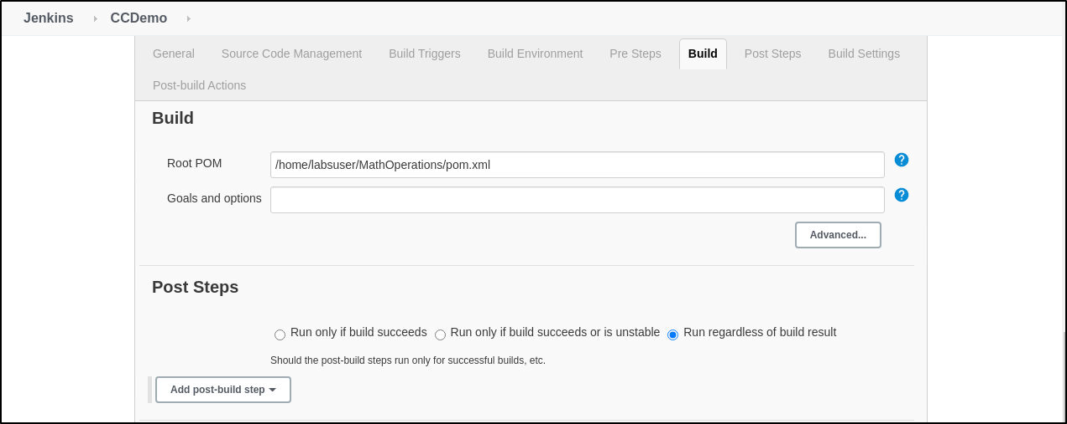
- Enter the Git repository URL of the project to pull the code from GitHub or provide the location of pom.xml file in your local system.
- Build the job.
- You can see the console output for the status of the build.

